**Arrays**

1. Array Initialization and Manipulation:
   1. Create an array of 5 numbers.
   2. Add a number to the end of the array.
   3. Remove the first number from the array.
   4. Print the final array.

**Program:**

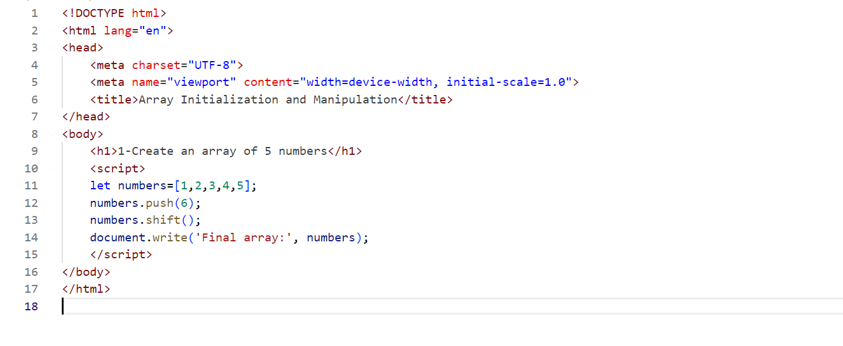

**Output:**

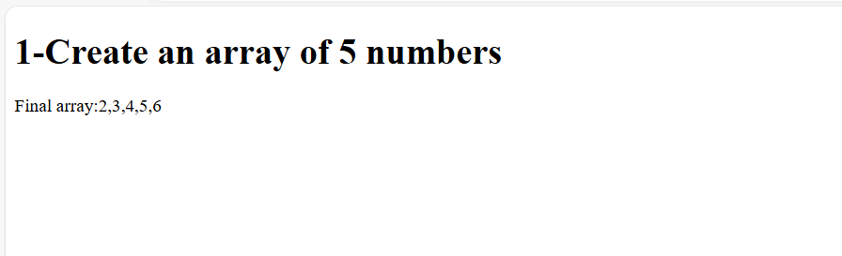

1. String Lengths in Array:
   1. Write a function that takes an array of strings and returns an array of their lengths.

**Program:**

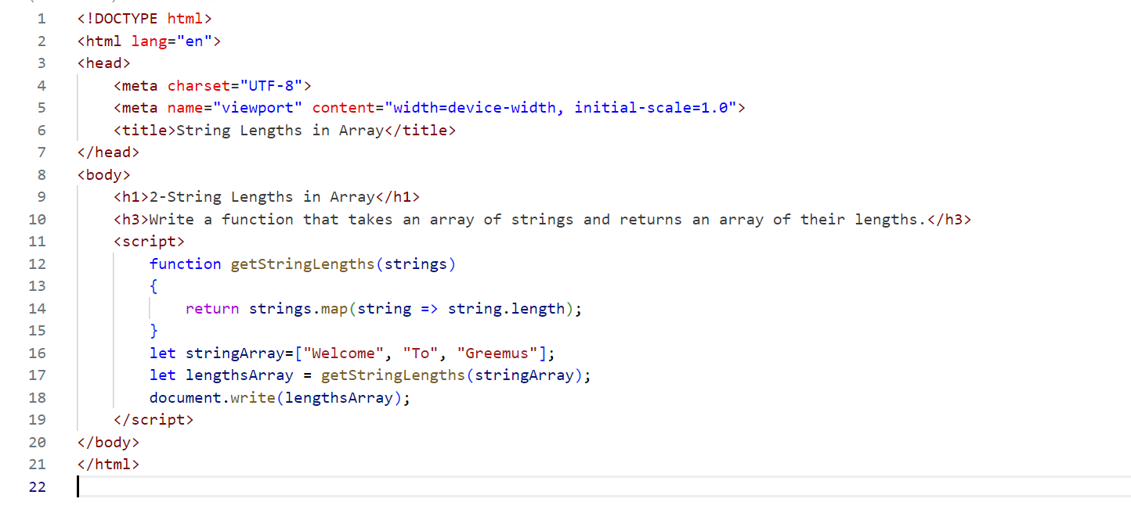

**Output:**

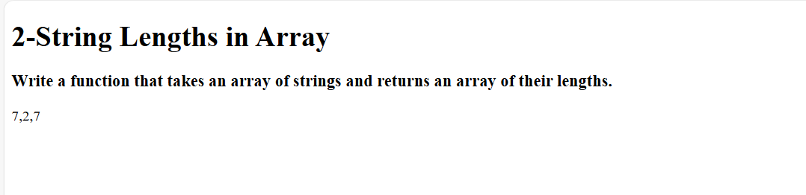

1. Filter Even Numbers:
   1. Write a function that takes an array of numbers and returns a new array containing only the even numbers.

**Program:**

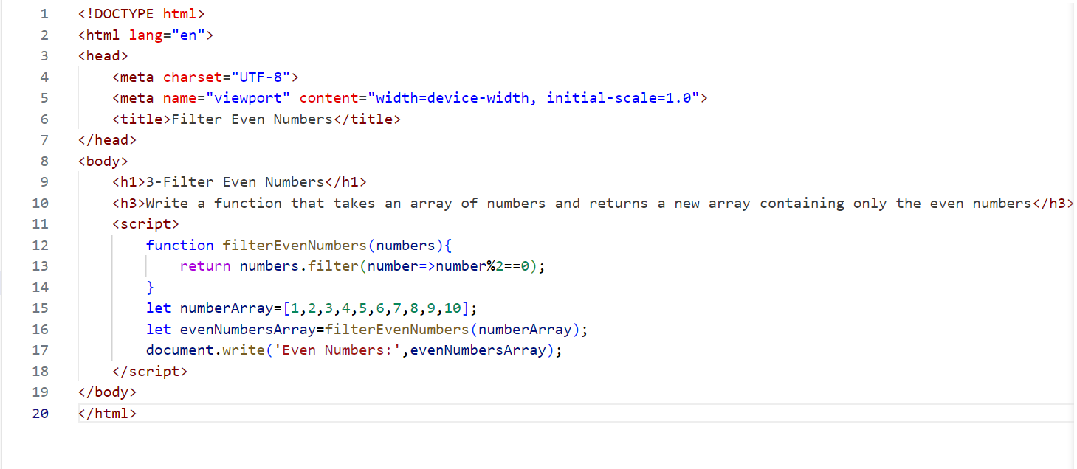

**Output:**

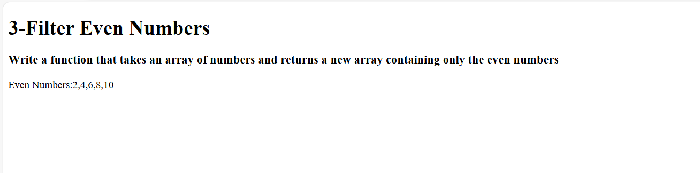

1. Reverse Strings:
   1. Write a function that takes an array of strings and returns a new array with each string reversed.

**Program:**

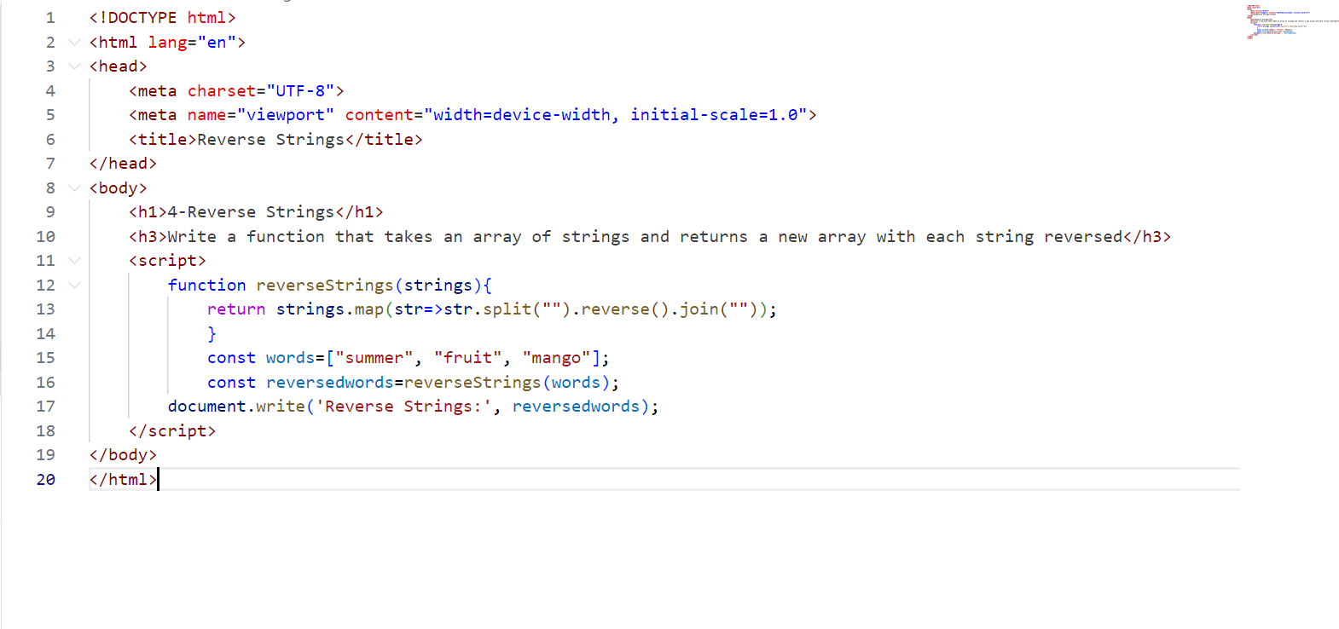

**Output:**

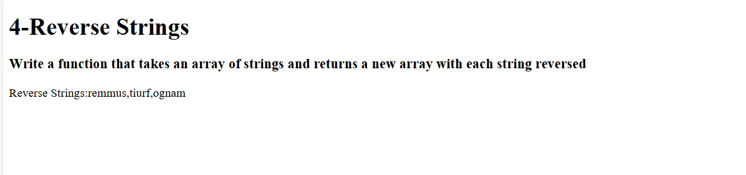

1. Sum of Array Elements:
   1. Write a function that takes an array of numbers and returns the sum of all the numbers.

**Program:**

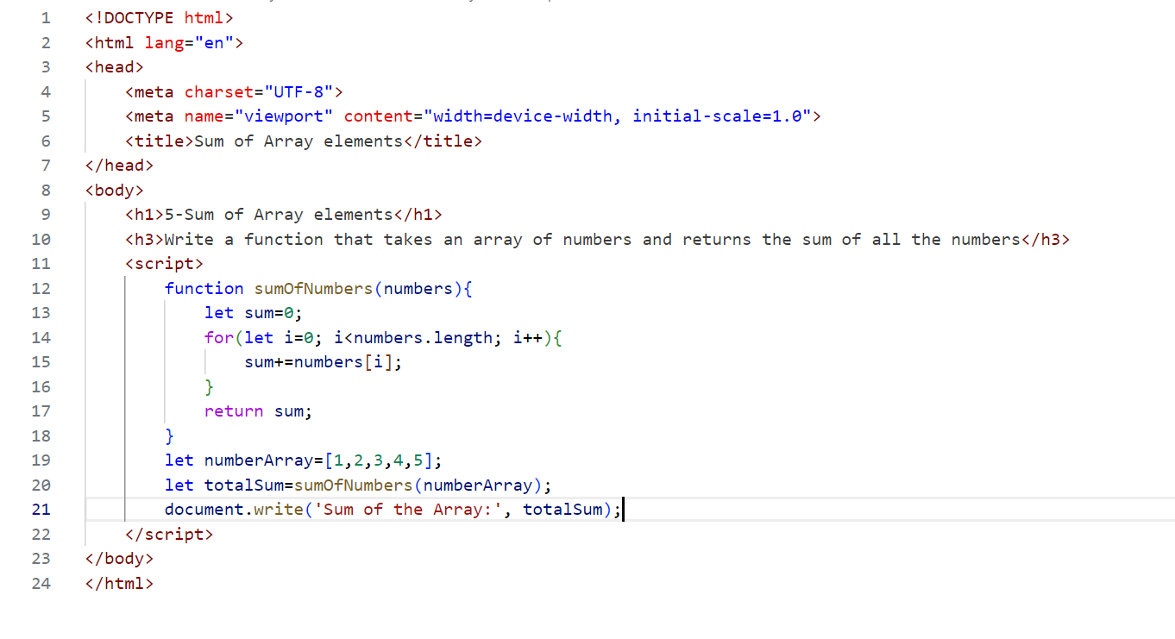

**Output:**

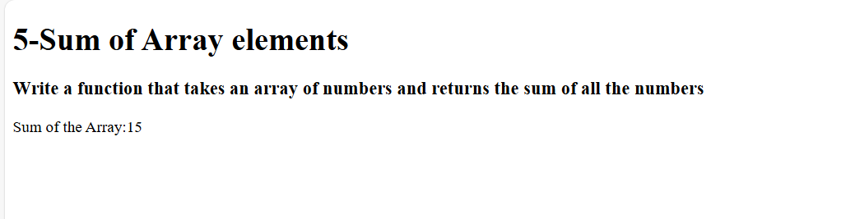

1. Find Longest String:
   1. Write a function that takes an array of strings and returns the longest string.

**Program:**

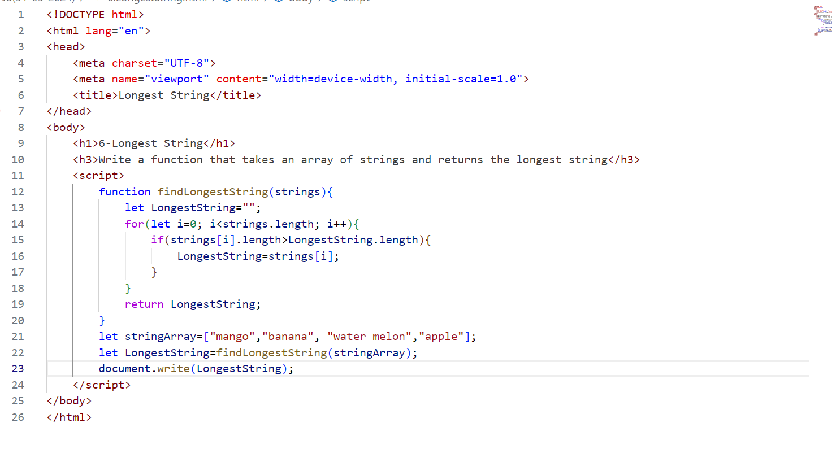

**Output:**

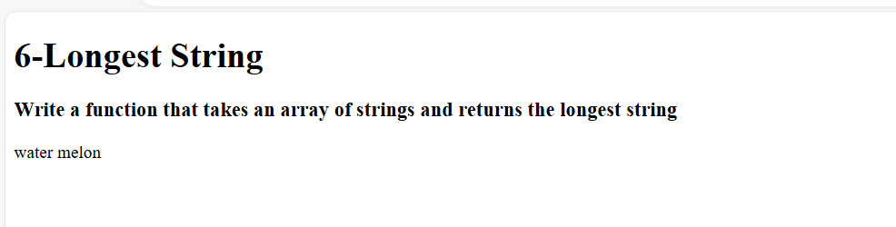

1. String Contains Character:
   1. Write a function that takes an array of strings and a character, and returns an array of strings that contain that character.

**Program:**

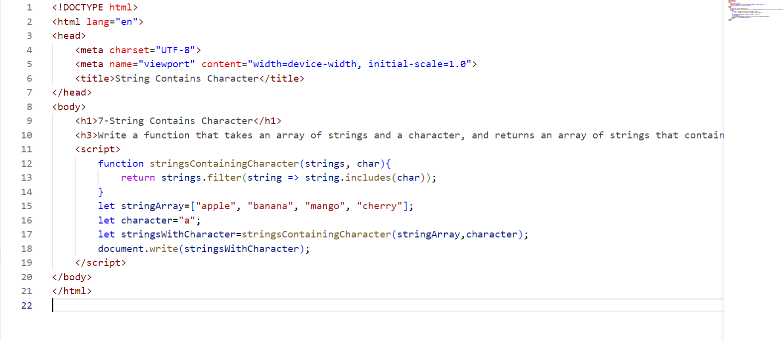

**Output:**

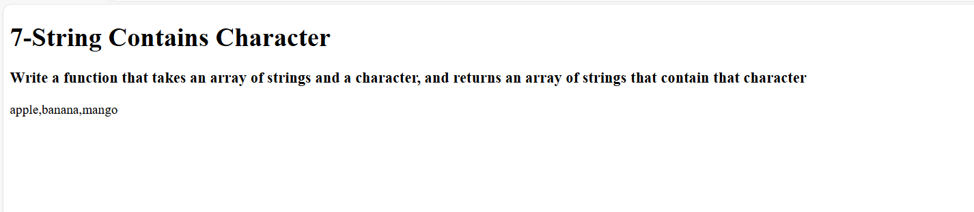

1. Concatenate Array of Strings:
   1. Write a function that takes an array of strings and returns a single string that is the concatenation of all the strings.

**Program:**

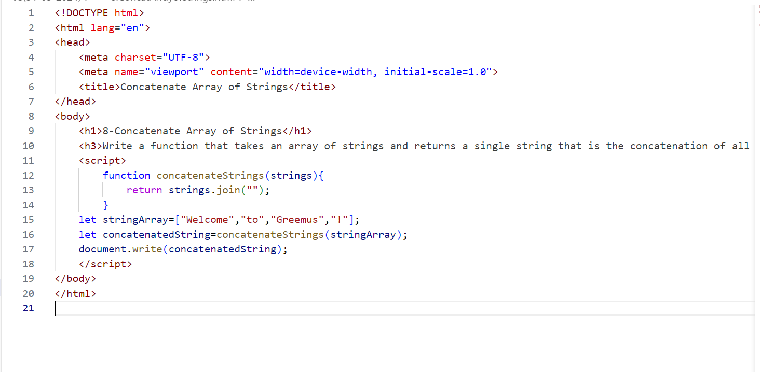

**Output:**

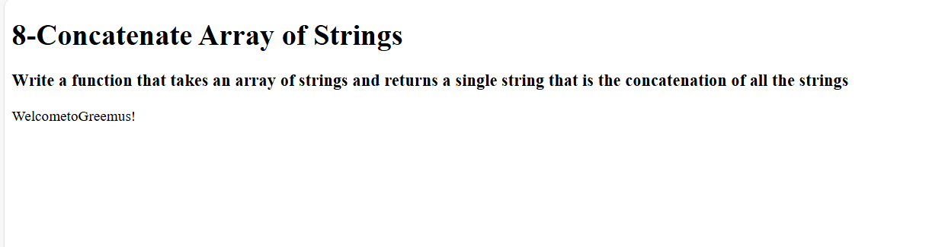

1. Capitalize First Letter:
   1. Write a function that takes an array of strings and returns a new array with the first letter of each string capitalized.

**Program:**

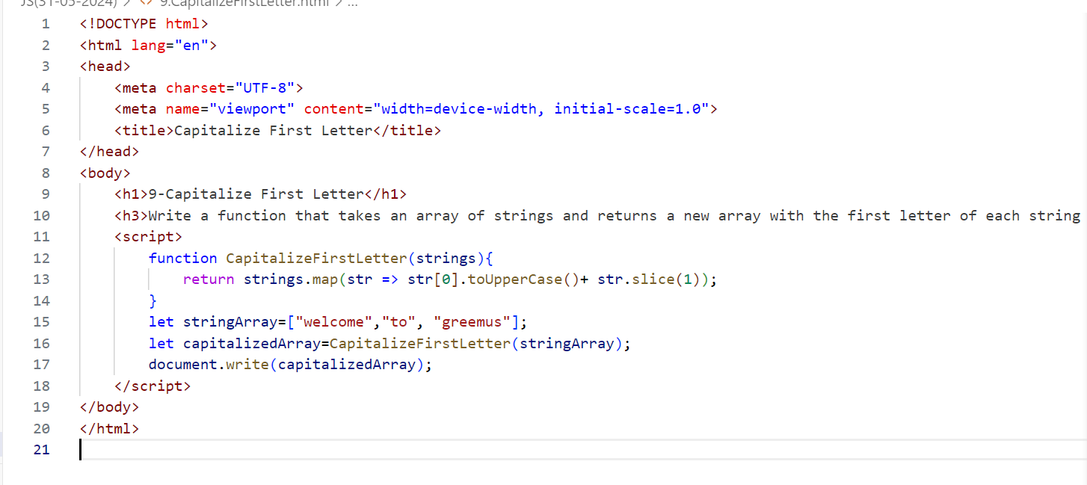

**Output:**

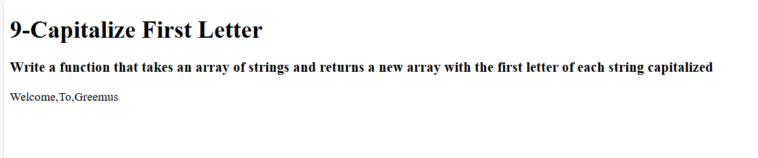

1. Flatten Nested Arrays:
   1. Write a function that takes a nested array (an array of arrays) and returns

**Program:**

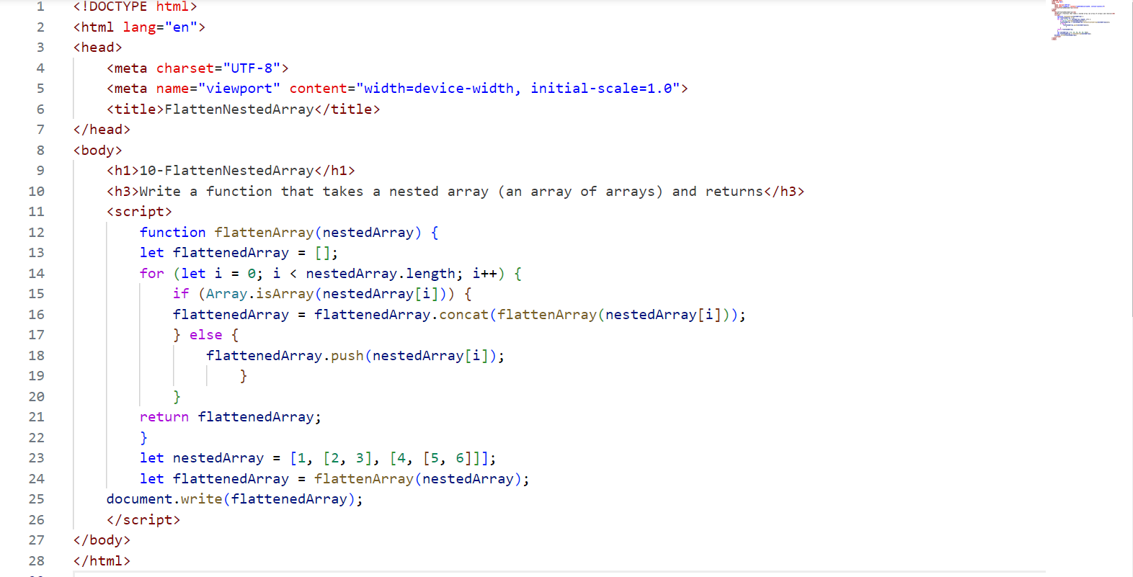

**Output:**

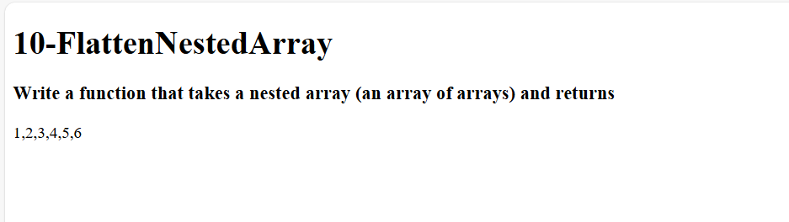

1. Count Occurrences:
   1. Write a function that takes an array of strings and returns an object where the keys are the strings and the values are the number of times each string appears in the array.

**Program:**

1. Remove Duplicates:
   1. Write a function that takes an array of numbers and returns a new array with all duplicate elements removed.

**Program:**

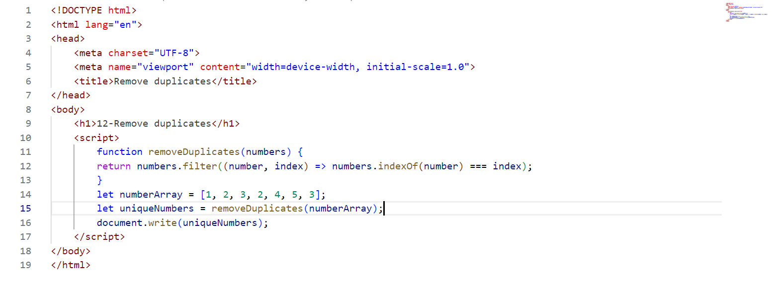

**Output:**

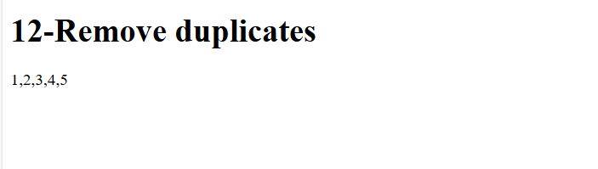

1. Find Index of String:
   1. Write a function that takes an array of strings and a string, and returns the index of the string in the array. If the string is not found, return -1.

**Program:**

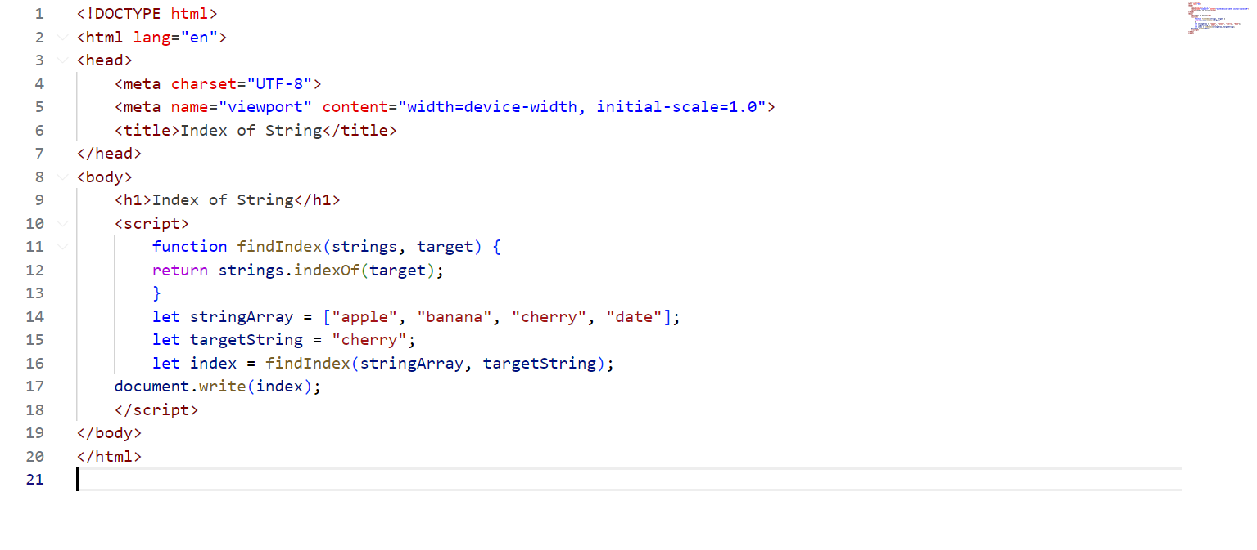

**Output:**

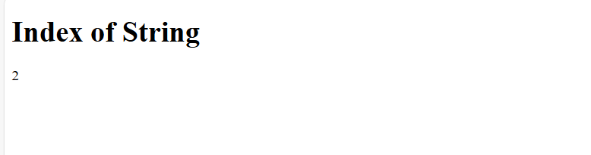

1. Sort Strings Alphabetically:
   1. Write a function that takes an array of strings and returns a new array with the strings sorted alphabetically.

**Program:**

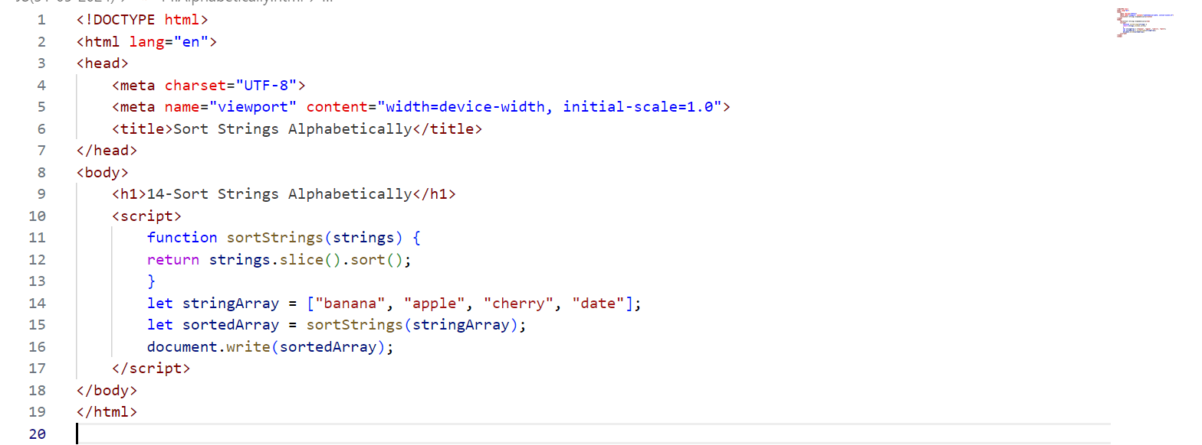

**Output:**

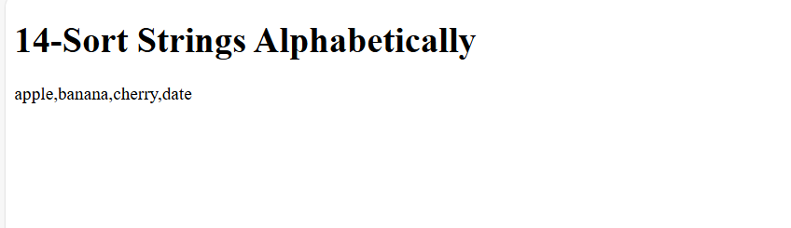

1. Sum of Square of Numbers:
   1. Write a function that takes an array of numbers and returns the sum of the squares of those numbers.

**Program:**

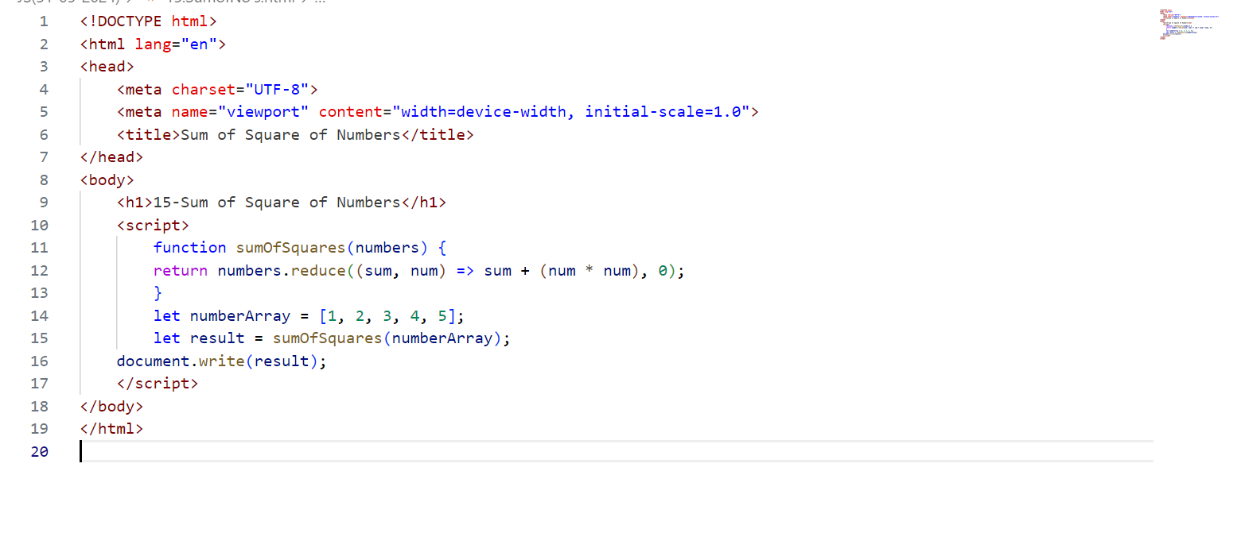

**Output:**

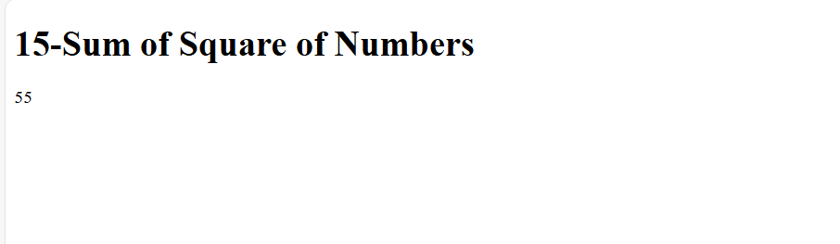

1. Convert Strings to Uppercase:
   1. Write a function that takes an array of strings and returns a new array with all the strings converted to uppercase.

**Program:**

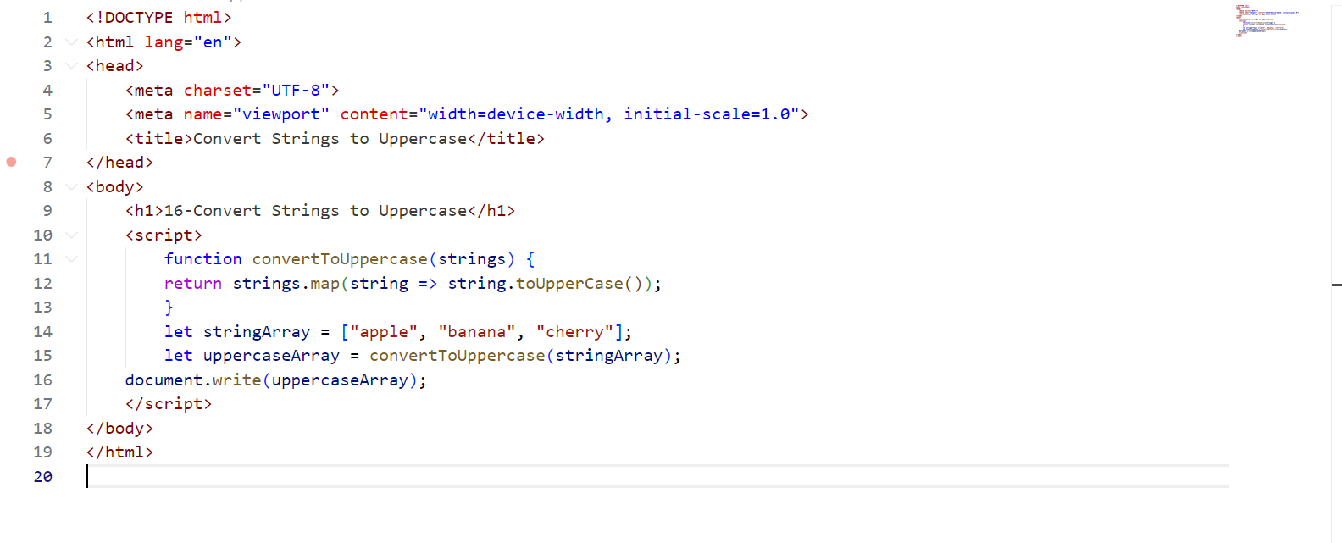

**Output:**

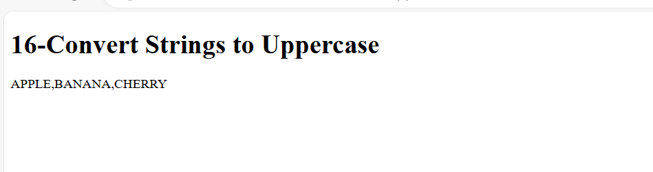

1. Find Common Elements:
   1. Write a function that takes two arrays of numbers and returns a new array containing the common elements from both arrays.

**Program:**

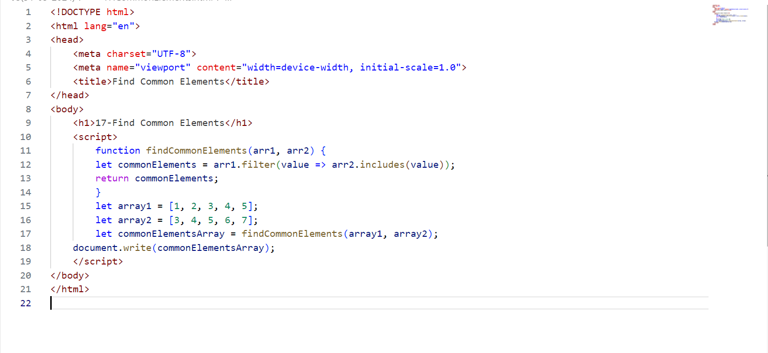

**Output:**

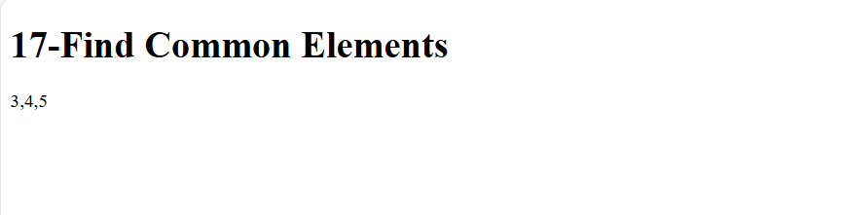

1. Remove Falsy Values:
   1. Write a function that takes an array and returns a new array with all falsy values (false, 0, "", null, undefined, NaN) removed.

**Program:**

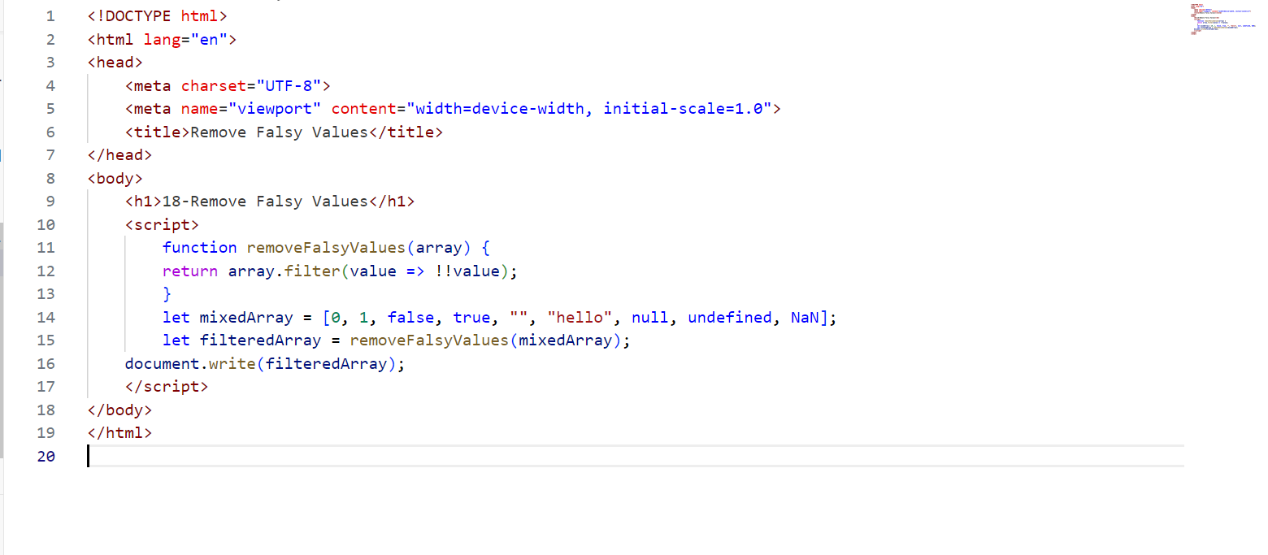

**Output:**

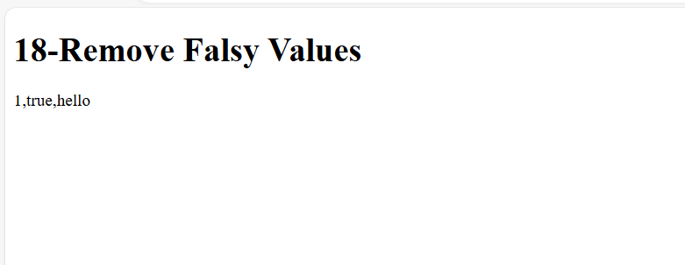

1. Find Unique Characters:
   1. Write a function that takes a string and returns an array of unique characters in the string.

**Program:**

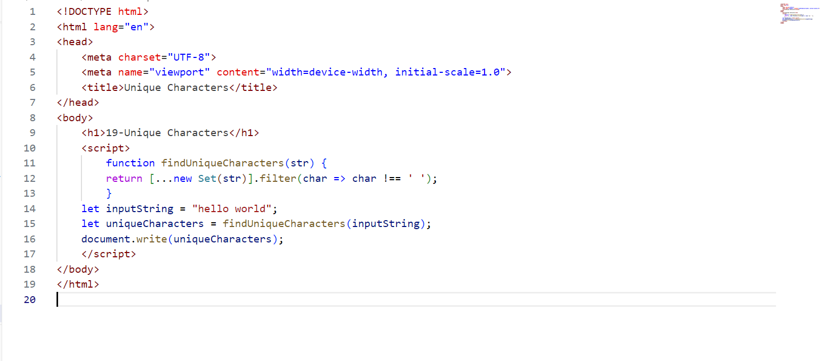

**Output:**

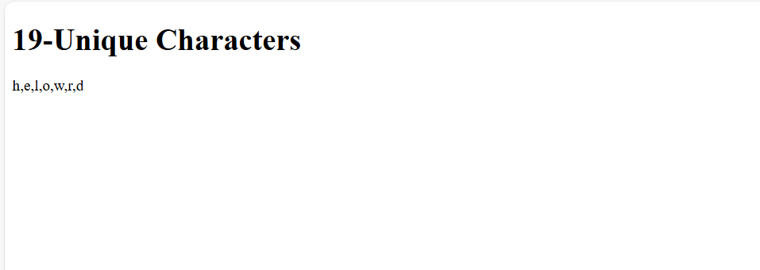

1. Merge and Sort Arrays:
   1. Write a function that takes two sorted arrays of numbers and returns a single sorted array that combines both arrays.

**Program:**

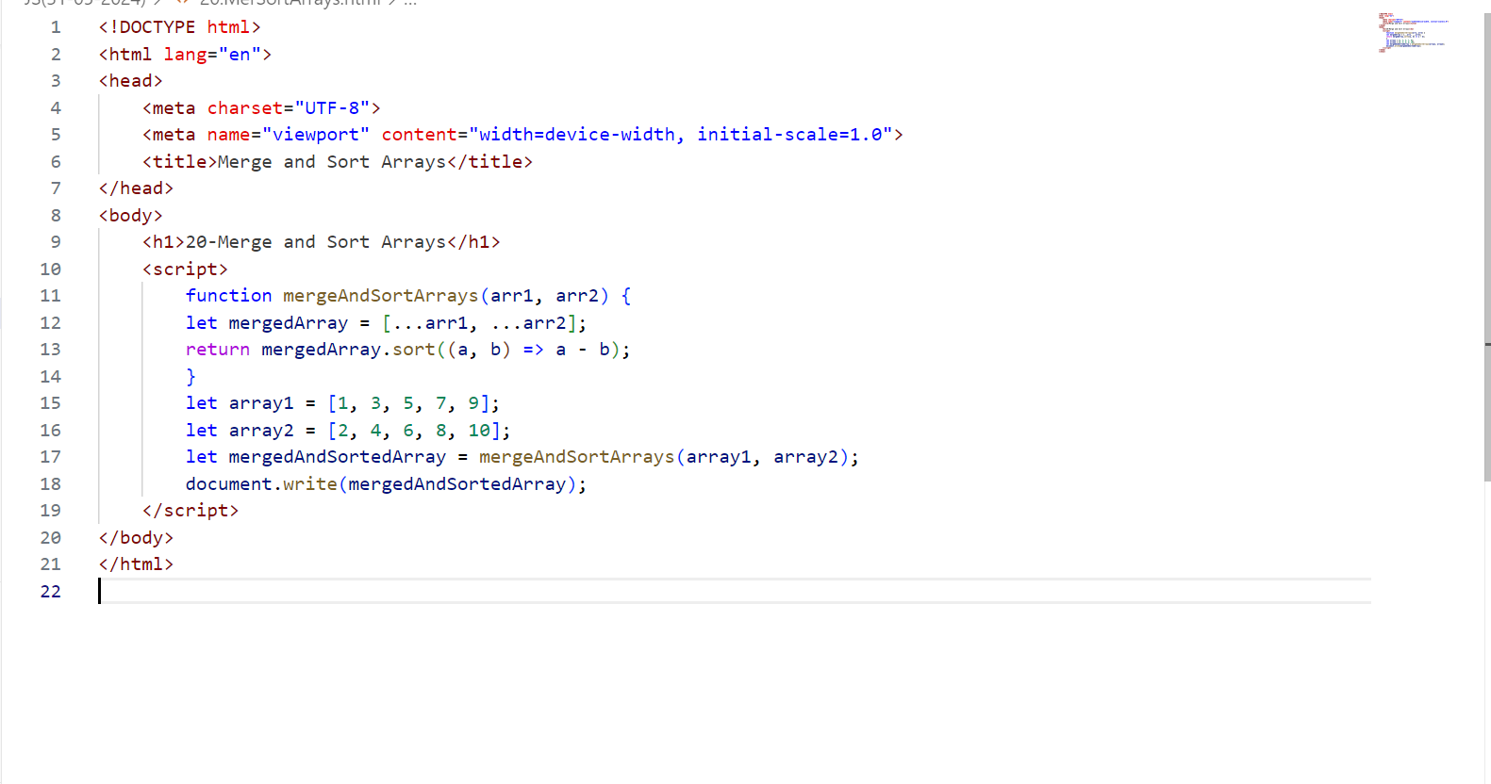

**Output:**

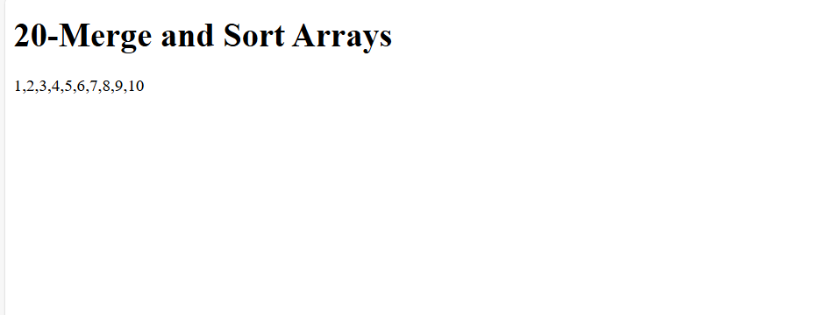

1. Count Occurrences:
   1. Write a function that takes an array of strings and returns an object where the keys are the strings and the values are the number of times each string appears in the array.
2. Remove Duplicates:
   1. Write a function that takes an array of numbers and returns a new array with all duplicate elements removed.

**Program:**



**Output:**



1. Find Index of String:
   1. Write a function that takes an array of strings and a string, and returns the index of the string in the array. If the string is not found, return -1.

**Program:**



**Output:**



1. Sort Strings Alphabetically:
   1. Write a function that takes an array of strings and returns a new array with the strings sorted alphabetically.

**Program:**



**Output:**



1. Sum of Square of Numbers:
   1. Write a function that takes an array of numbers and returns the sum of the squares of those numbers.

**Program:**



**Output:**



1. Convert Strings to Uppercase:
   1. Write a function that takes an array of strings and returns a new array with all the strings converted to uppercase.

**Program:**



**Output:**



1. Find Common Elements:
   1. Write a function that takes two arrays of numbers and returns a new array containing the common elements from both arrays.

**Program:**



**Output:**



1. Remove Falsy Values:
   1. Write a function that takes an array and returns a new array with all falsy values (false, 0, "", null, undefined, NaN) removed.

**Program:**



**Output:**



1. Find Unique Characters:
   1. Write a function that takes a string and returns an array of unique characters in the string.

**Program:**



**Output:**



1. Merge and Sort Arrays:
   1. Write a function that takes two sorted arrays of numbers and returns a single sorted array that combines both arrays.

**Program:**



**Output:**

